PRIORITY INVERSION
Wednesday, December 13, 2023
11:14 AM

Priority Inversion :

Priority inversion is a bug that occurs when a high priority task is indirectly preempted by a low priority task. For example, the low priority task holds a mutex that the high priority task must wait for to continue executing.

Bounded priority inversion.

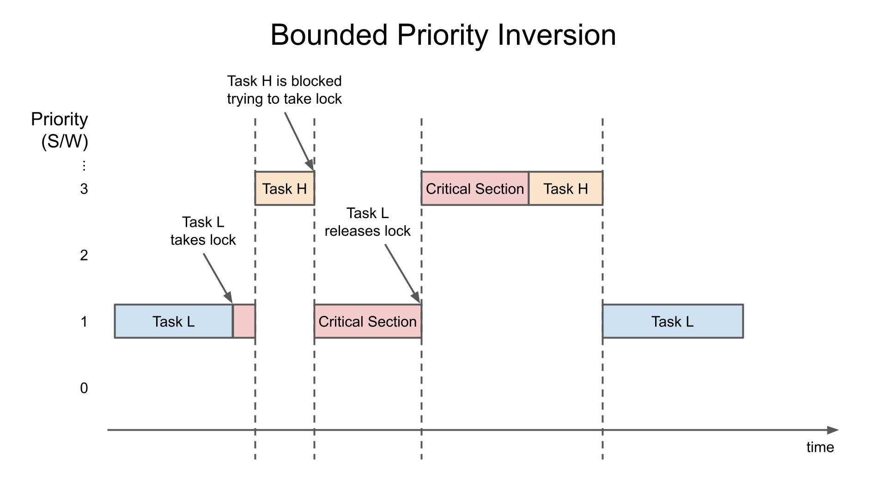

--> here we have task - L which is a low priority task its starts running and enters critical section by using mutex or semaphores , a high priority task task - H interrupts , its starts to enter the execution in the critical section but already the task - l is making lock so it blocks task - H and now scheduler return to finish the task -L in the critical section to execution .
--> when the task - L release the lock the scheduler unlocks the task - H and enter the critical section and performs the task and after execution everything It will again assign to task - L Bounded priority inversion.

Unbounded priority inversion :

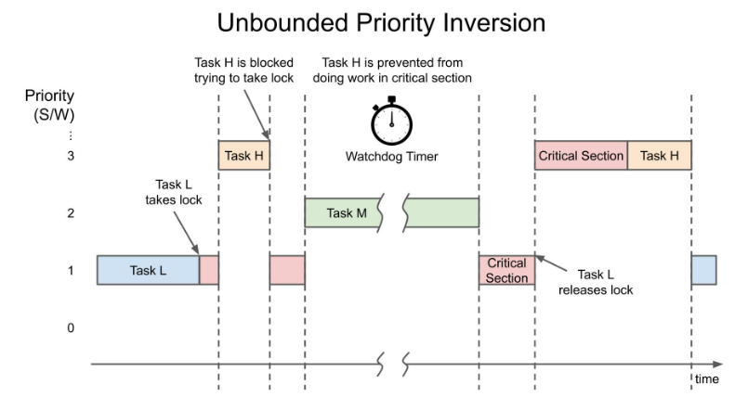

--> here we avoid bounded priority because critical section is less time but here we get unbounded priority when new task come into picture.

--> here task -L is executing in critical section by applying mutex lock , task - H try to take lock but it will be blocked.
--> Normally after executing task -L it release lock task - H takes over the lock but there a mid-level task entered .
--> The task -M executes when task -L is in critical section and executes it process now task -H needs to wait until task -M release complete then task -L completed it critical section and then release the lock and it will now be acquired by task - H.
--> after that it is given to the task -L.
--> There is a watch dog timer which will reset the timer if task - M does not complete execution for particular time period .
--> By this bounded priority is reduced but unbounded priority is occurred.

Priority ceiling inversion :

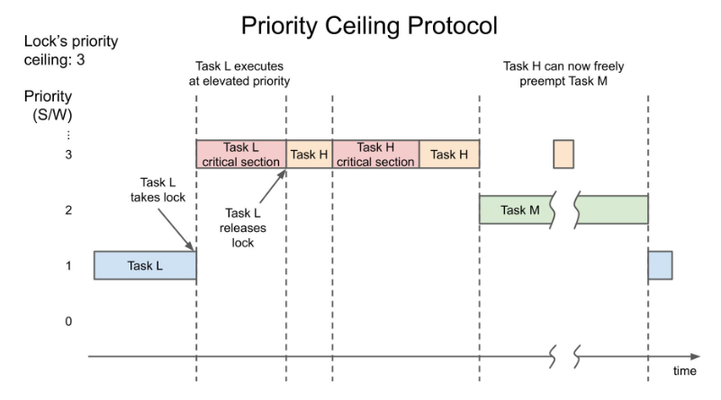

--> To avoid the unbounded priority inversion we use priority ceiling inversion but It has the problem of bounded priority.
--> here we make the ceiling value for the resource used .
-->Here we have task - L which takes the lock and priority is boosted automatically.
-->when task -H is trying to access it is blocked until task - L is completed.
-->after that task - H is taken lock until it completed I will not allow other task after completing it allows task - M
--> in task - M task - H can interfere in critical section as well after completing that it will again assign to task - L
--> by this we avoid unbound priority inversion.

Priority inheritance :

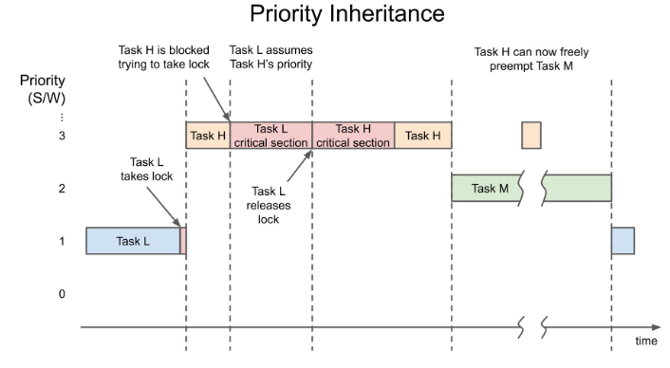

-->Here the task - L is acquiring the lock and running , now task - H try to acquire the lock then It will be in block state.
-->After sometime task _ L works in critical situation after releasing the lock task - H will acquire the lock and task - H starts executing.
-->After that task -M comes where we can use task-H that which can start execution in the critical section.

RTOS
Wednesday, December 13, 2023
4:41 PM

To work on RTOS we need to go basic things like operating system , processes , threads , semaphores , mutex , etc

What is system ?

A system is a process or collection of processes and it does certain clearly defined objectives in an apparently independent way.

What is operating system ?

An operating system is a set of programs, designed to manage all the resources of the computer. In other words, a set of programs that acts as an intermediary between a user of a computer and the computer hardware.

Memory, I/O devices, communication devices, etc. are the hardware resources of the computer. File systems, virtual memory, security, etc. are software resources. Now a set of programs that are used to manage all these resources is called an operating system.
More narrowly, to refer to the central software that manages and allocates computer resources (i.e., the CPU, RAM, and devices)

Need for operating system :

- Without an operating system, a user cannot run an application program on their computer, unless the application program is self-booting.
- Execute user programs and make solving user problems easier.
- Use the computer hardware in an efficient manner.

System components :

- Hardware - basic resources in a computer (CPU , Memory , I/O devices
- Operating system - controls and coordinates the use of the hardware among the various application programs for the various users.
- Application programs -
- User - People , machines , other computers.

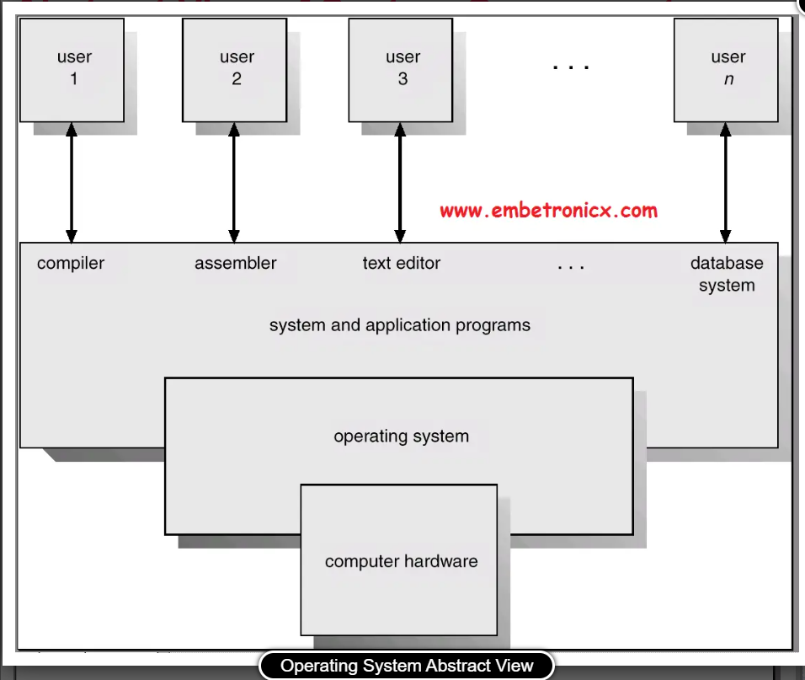

Function of operating system :

- Process management

- Memory management

- Secondary storage management

- I/O management

- File management

- Protection

- Networking management

- Command Interpretation

Main tasks performed in process management :
- Process creation
- Process loading
- Process execution control
- Interaction of the process with signal events
- Process monitoring
- CPU allocation
- Process termination

PROCESS
Thursday, December 14, 2023
3:55 PM

What is a process ?
It is an instance of an executing program , When a program is executed, the kernel loads the code of the program into virtual memory, allocates space for program variables, and sets up kernel bookkeeping data structures to record various information (such as process ID, termination status, user IDs, and group IDs) about the process.

Program:
A program is a file containing a range of information that describes how to construct a process at run time.

Process memory layout :

Here the process is logically divided into 4 parts :
1 - text - which has the instruction of the program.
2 - Data - it is the static variable used by the program.
3 - Heap - an area where we can dynamically allocate extra memory.
4 - Stack - It is memory that grows when function is called and sink when function completes execution.

Process creation and process execution :

A process can create a new process by using fork system call. The process that call fork is called parent process , new process is referred as child process.
Child is created by the duplicate of parent process.
The child copies all the parent's data , heap , stack segment and it will modify later. The above three are shared but the text is marked as the read-only so it will be shared by the two process.
Now the child will execute particular function in the same code as parent or calls the execve() system Call.
The execve() system call destroys all the existing stack , heap , text and data and replace with new heap , data , stack and text , that is like totally a new program.

Process termination and termination status :

The process termination can be done in two ways :
1 - by requesting its own termination using _exit system call.
2 - by being killed by the delivery of signal.
By the above two methods it will leave a non - negative integer value for inspection by parent using wait system call
The return value is 0 then the process termination is succeeded.
Non zero value indicates some error.

Init process :
It is noting but the first process which has process id as 1 which is the first parent process.
It will have superuser privilages. This process cannt be killled and it terminates once the system is shutdown.
The main task of init is to create and monitor a range of processes required by a running system.

Daemon process :
A daemon is a special-purpose process that is created and handled by the system in the same way as other processes, but which is distinguished by the following characteristics:
It is long-lived. A daemon process is often started at system boot and remains in existence until the system is shut down.
It runs in the background, and has no controlling terminal from which it can read input or to which it can write output.

Process ID and Parent process ID :

Every process in the system has a process ID , a positive integer the uniquely identifies the process on the system.
Getpid() system call is used to return the process ID
The limit of process Id's are less than are equal to 32767, whenever process is created it assigns the number between this range.
Once the limit is completed then it will reset the number from start lower values that starts from 300 instead of 1.
Because the lower 300 are already registered and used by process , daemon process.
PID_MAX = 32767

EXEC() library : -

1 - Execve
2 - elecle
3 - eleclp
4 - execvp
5 -execv
6 -execl

Virtual memory management :
The aim of this technique is to make efficient use of both the CPU and RAM (physical memory) by exploiting a property that is typical of most programs.

Fork()
The fork() system call creates a new process, the child, which is an almost exact duplicate of the calling process, the parent.

SYSTEM CALL
Friday, December 15, 2023
12:15 PM

What is system call ?
A system call is a control entry point into the kernel , allowing the process to request the kernel to perform some task behalf of process

General points of system call :
- A system call changes the processor state from user mode to kernel mode, so that the CPU can access protected kernel memory.
- The set of system calls is fixed. Each system call is identified by a unique number.
- Each system call may have a set of arguments that specify information to be transferred from user space (i.e., the process’s virtual address space) to kernel space and vice versa.

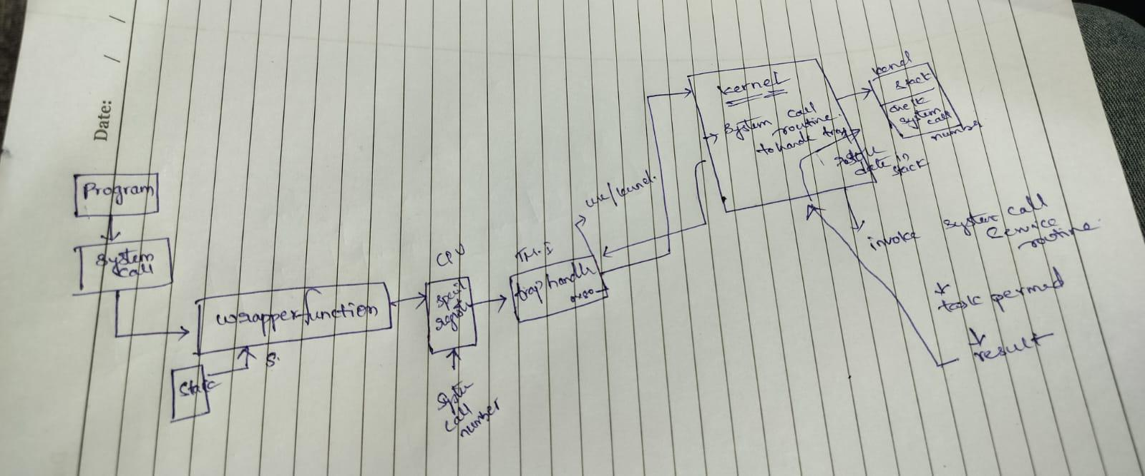

INTERPROCESS COMMUNICATION
Wednesday, December 13, 2023
11:08 PM

What and why we use interprocess communication :
A running Linux system consists of numerous processes, many of which operate independently of each other. Some processes, however, cooperate to achieve their intended purposes, and these processes need methods of communicating with one another and synchronizing their actions.
One way for processes to communicate is by reading and writing information in disk files. However, for many applications, this is too slow and inflexible.

Mechanism for IPC(Interprocess communication) :
1 - signals - this indicates event has occurred.
2 - pipes - used to transfer data between process
3 - sockets - which can be used to transfer data from one process to another, either on the same host computer or on different hosts connected by a network
4 - file locking - which allows a process to lock regions of a file in order to prevent other processes from reading or updating the file contents
5 - message queues - which are used to exchange messages (packets of data) between processes.
6 - semaphores - which are used to synchronize the actions of processes
7 - shared memory - which allows two or more processes to share a piece of memory. When one process changes the contents of the shared memory, all of the other processes can immediately see the changes.

Overview of IPC:

Communication :- exchanging data between processes.
Synchronization :- synchronizing the actions of processes or threads.
Signals :- : Although signals are intended primarily for other purposes, they can be used as a synchronization technique in certain circumstances. More rarely,signals can be used as a communication technique: the signal number itself is a form of information, and realtime signals can be accompanied by associated data (an integer or a pointer).

IPC is decribed as below :
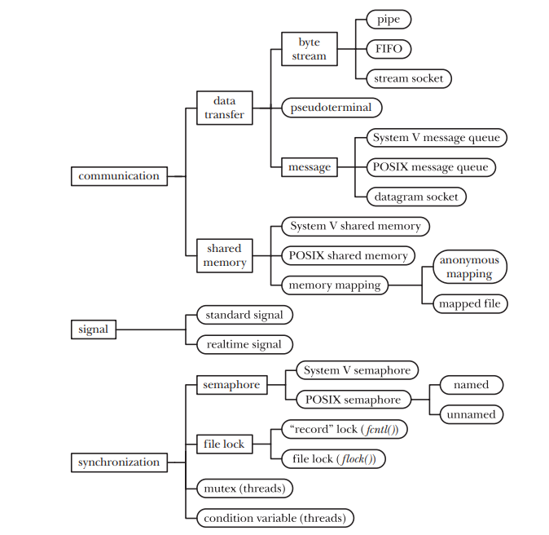

Communication facilities :

The communication facilities are into 2 types :
1 - Data transfer facilities
2 - Shared memory
1 - Data transfer
The key factor distinguishing these facilities is the notion of writing and reading. In order to communicate, one process writes data to the IPC facility, and another process reads the data. These facilities require two data transfers between user memory and kernel memory: one transfer from user memory to kernel memory during writing, and another transfer from kernel memory to user memory during reading.
2 - Shared memory
Shared memory allows processes to exchange information by placing it in a region of memory that is shared between the processes. A process can make data available to other processes by placing it in the shared memory region. Because communication doesn’t require system calls or data transfer between user memory and kernel memory, shared memory can provide very fast communication.

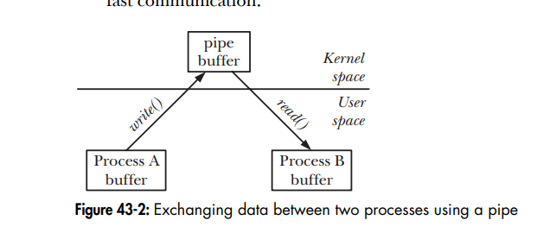
Data transfer :
Further we break this data transfer into following subcategories :
1 - Byte stream - The data exchanged via pipes, FIFOs, and datagram sockets is an undelimited byte stream.
2 - message - The data exchanged via System V message queues, POSIX message queues, and datagram sockets takes the form of delimited messages.
3 - pseudo terminals - A pseudo terminal is a communication facility intended for use in specialized situations.
Data transfer facilities from shared memory :
Although a data-transfer facility may have multiple readers, reads are destructive. A read operation consumes data, and that data is not available to any other process

Synchronization between the reader and writer processes is automatic. If a reader attempts to fetch data from a data-transfer facility that currently has no data, then (by default) the read operation will block until some process writes data to the facility

Shared memory:
Although shared memory provides fast communication, this speed advantage is offset by the need to synchronize operations on the shared memory. For example, one process should not attempt to access a data structure in the shared memory while another process is updating it. A semaphore is the usual synchronization method used with shared memory.
Data placed in shared memory is visible to all of the processes that share that memory.

/////////////////////////////////////////////////////////////////////////////////////////////////////////////////////////////////////////////////////////////////////////////////////////

PIPES AND FIFO

We can think of a pipe as a piece of plumbing that allows data to flow from one process to another.

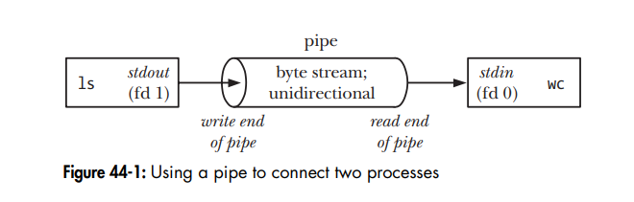
One point to note in Figure 44-1 is that the two processes are connected to the pipe so that the writing process (ls) has its standard output (file descriptor 1) joined to the write end of the pipe, while the reading process (wc) has its standard input (file descriptor 0) joined to the read end of the pipe. In effect, these two processes are unaware of the existence of the pipe; they just read from and write to the standard file descriptors.

The commands and descriptors used to create pipes :
To create :
Int pipe(int pipefd[2]);
Here we create 2 file descriptors one for read and one for write.
Write --> fd[1]
Read --> fd[0]
The return values of pipe is 0 on success and -1 on error in creating the pipe.

To write to pipe we use write and read , the syntax for that is :

Read command with arguments and return value

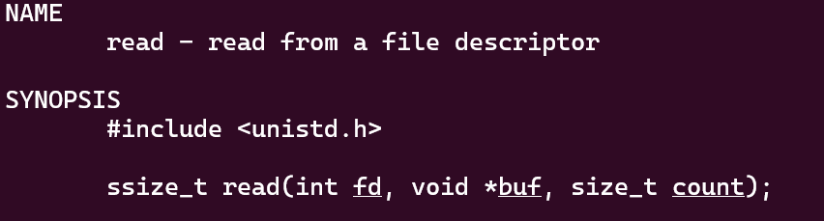

We use the file descriptor , to read is 0 , second argument buff name , 3rd argument the size of buffer.

On successfully read it return 0 on failure it return -1.

Write command with arguments and return value
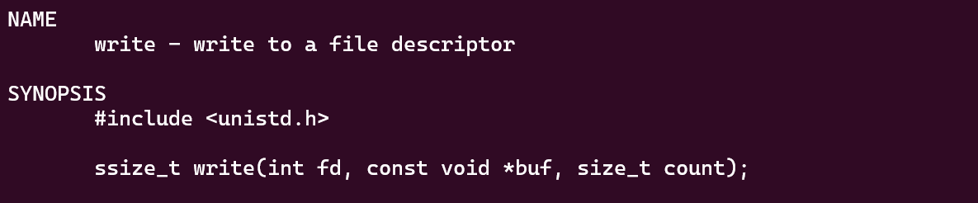

We use the file descriptor , to write is 1 , second argument buff name , 3rd argument the size of buffer.

On successfully read it return 0 on failure it return -1

Fork() :

We use fork to create child process to communicate between related process.

We create fork with the return value as 0 if created else -1 will be returned.
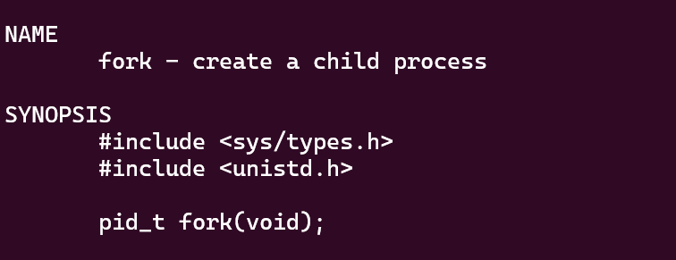

Example program to communicate b/w parent and child process ::::

#include <stdio.h>
#include <stdlib.h>
#include <unistd.h>
#include <fcntl.h>
#include <sys/wait.h>
#define MAX 128
int main() {

int fd[2];
int pid;
if(pipe(fd) == -1) {
printf("error in creatig pipe");
}

pid = fork();

if(pid == -1) {
printf("error in creating child process:");
}

if(pid > 0) {
printf("sending msg from parent:\n");
close(fd[0]);
//char buff[MAX];
if(write(fd[1] , "hehehhbe" , 9) == -1) {
printf("error in writing ::");
}
close(fd[1]);
} else {
close(fd[1]);
char buff[MAX];
if(read(fd[0] ,buff, 9) == -1 ) {
printf("error in reading ::");
}
printf("the msg from parent:%s", buff);
close(fd[0]);
}
}

FIFO :

Semantically, a FIFO is similar to a pipe. The principal difference is that a FIFO has a name within the file system and is opened in the same way as a regular file. This allows a FIFO to be used for communication between unrelated processes. FIFOs are also sometimes known as named pipes.

We can create a FIFO from the shell using the mkfifo command.
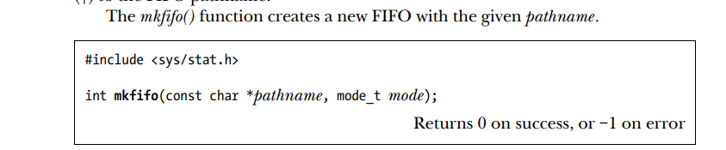

Creation of mkfifo :
#include <stdio.h>
#include <stdlib.h>
#include <sys/stat.h>

int main () {

int res;
if(res = mkfifo("new_fifo" , 0777) == 0) {
printf("fifo is created:::");
}
}

Now above program creates fifo now we can send and receive data through fifo as client and server.

SIGNALS
Monday, December 18, 2023
11:06 AM

Signals :
A signal is a notification to a process that an event has occurred. Signals are sometimes described as software interrupts.
One process can (if it has suitable permissions) send a signal to another process.
Each signal is defined as a unique (small) integer, starting sequentially from 1. These integers are defined in with symbolic names of the form SIGxxxx. Since the actual numbers used for each signal vary across implementations, it is these symbolic names that are always used in programs.

Signals fall under two categories :
1 - traditional signals
2 - standard signals
These are used by kernel to notify processes of events.

Here the standard signals are numbered from 1 - 31

A signal is said to be generated by some event. Once generated, a signal is later delivered to a process, which then takes some action in response to the signal. Between the time it is generated and the time it is delivered, a signal is said to be pending.

Upon delivery of a signal, a process carries out one of the following default actions, depending on the signal:
- The signal is ignored; that is, it is discarded by the kernel and has no effect on the process. (The process never even knows that it occurred).
- The process is terminated (killed). This is sometimes referred to as abnormal process termination, as opposed to the normal process termination that occurs when a process terminates using exit().
- A core dump file is generated, and the process is terminated. A core dump file contains an image of the virtual memory of the process, which can be loaded into a debugger in order to inspect the state of the process at the time that it terminated.
- The process is stopped—execution of the process is suspended.
- Execution of the process is resumed after previously being stopped.

Signal handler :
A signal handler is a function, written by the programmer, that performs appropriate tasks in response to the delivery of a signal. For example, the shell has a handler for the SIGINT signal

Different signal types :

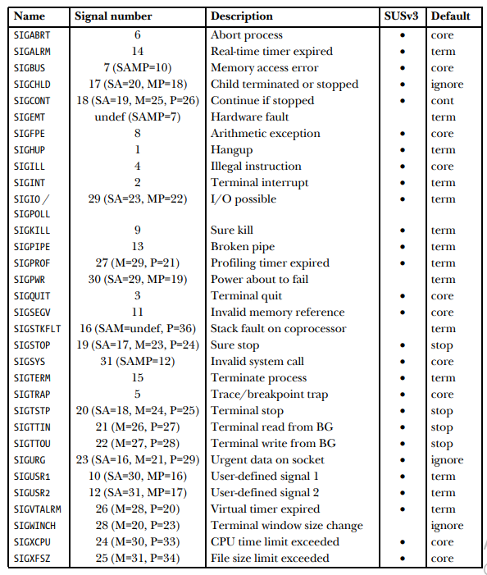

Signal Dispositions:
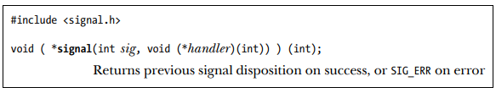
The function prototype for signal() requires some decoding. The first argument, sig, identifies the signal whose disposition we wish to change. The second argument, handler, is the address of the function that should be called when this signal is delivered. This function returns nothing (void) and takes one integer argument.

Thus, a signal handler has the following general form
void handler(int sig)
{
/* Code for the handler */

}

Signal handlers :

A signal handler (also called a signal catcher) is a function that is called when a specified signal is delivered to a process
Invocation of a signal handler may interrupt the main program flow at any time; the kernel calls the handler on the process’s behalf, and when the handler returns, execution of the program resumes at the point where the handler interrupted it.

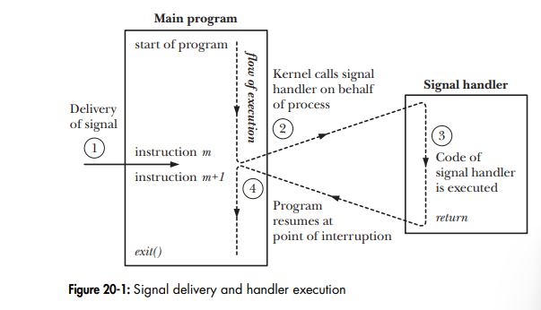

Example program to create a one signal handler :

#include <signal.h>
#include <stdio.h>
#include <unistd.h>
//#include "tlpi_hdr.h"
static void
sigHandler(int sig)
{
printf("Ouch!\n"); /* UNSAFE (see Section 21.1.2) */
}
int main(int argc, char *argv[])
{
int j;
if (signal(SIGQUIT, sigHandler) == SIG_ERR) {
printf("error in signal");
}
for (j = 0; ; j++) {
printf("%d\n", j);
sleep(3); /* Loop slowly... */
}
}

Example program to create a two signal handler :

#include <signal.h>
#include <stdio.h>
#include <stdlib.h>
#include <unistd.h>

static void
sigHandler(int sig)
{
static int count = 0;
/* UNSAFE: This handler uses non-async-signal-safe functions
(printf(), exit(); see Section 21.1.2) */
if (sig == SIGINT) {
count++;
printf("Caught SIGINT (%d)\n", count);
return; /* Resume execution at point of interruption */
}
/* Must be SIGQUIT - print a message and terminate the process */
printf("Caught SIGQUIT - that's all folks!\n");
exit(EXIT_SUCCESS);
}
int main(int argc, char *argv[])
{
/* Establish same handler for SIGINT and SIGQUIT */
if (signal(SIGINT, sigHandler) == SIG_ERR) {
printf("error in signal");
}
if (signal(SIGQUIT, sigHandler) == SIG_ERR) {
printf("error in signal");
}
for (;;) /* Loop forever, waiting for signals */
pause(); /* Block until a signal is caught */
}

Friday, December 15, 2023
4:07 PM

interprocess communication
1 - pipes
-> 2 types
2 - message queue
3 - semaphores
4 - shared memory
5 - socket
-----------
6 - threads & mutex

MQTT
Wednesday, August 28, 2024
6:23 PM

What is MQTT ?

MQTT is a light weight publish / subscribe messaging protocol designed for machine to machine telemetry in low bandwidth environments.

It was designed by Andy Stanford-Clark (IBM) and Arlen Nipper in 1999 for connecting Oil Pipeline telemetry systems over satellite.

Although it started as a proprietary protocol it was released Royalty free in 2010 and became an OASIS standard in 2014.

OASIS (Organization for the Advancement of Structured Information Standards)
MQTT stands for MQ Telemetry Transport but previously was known as Message Queuing Telemetry Transport.
MQTT is fast becoming one of the main protocols for IOT (internet of things) deployments.

http://www.steves-internet-guide.com/mqtt-works/ -- Reference

How Does MQTT Work ?-MQTT is a messaging protocol i.e it was designed for transferring messages, and uses a publish and subscribe model.
This model makes it possible to send messages to 0,1 or multiple clients.
A useful analogy is TV or radio.
A TV broadcaster broadcasts a TV program using a specific channel and a viewer tunes into this channel to view the broadcast.
There is no direct connection between the broadcaster and the viewer.
In MQTT a publisher publishes messages on a topic and a subscriber must subscribe to that topic to view the message.
MQTT requires the use of a central Broker as shown in the diagram below:

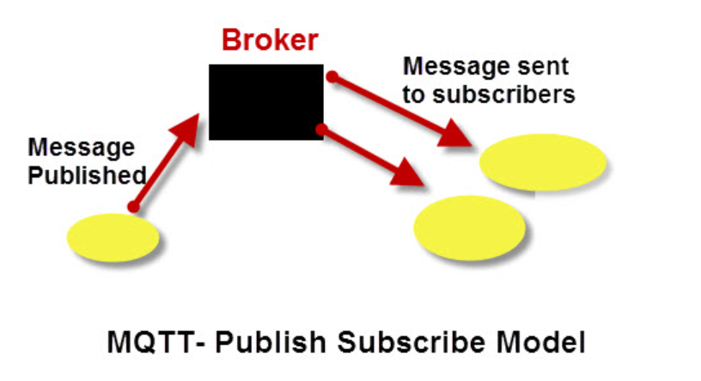
Important Points to Note
  - Clients do not have addresses like in email systems, and messages are not sent to clients.
  - Messages are published to a broker on a topic.
  - The job of an MQTT broker is to filter messages based on topic, and then distribute them to subscribers.
  - A client can receive these messages by subscribing to that topic on the same broker
  - There is no direct connection between a publisher and subscriber.
  - All clients can publish (broadcast) and subscribe (receive).
  - MQTT brokers do not normally store messages.

MQTT Client broker connections

MQTT uses TCP/IP to connect to the broker.
TCP is a connection orientated protocol with error correction and guarantees that packets are received in order.
You can consider a TCP/IP connection to be similar to a telephone connection.
Once a telephone connection is established you can talk over it until one party hangs up.
Most MQTT clients will connect to the broker and remain connected even if they aren’t sending data.
Connections are acknowledged by the broker using a Connection acknowledgement message.

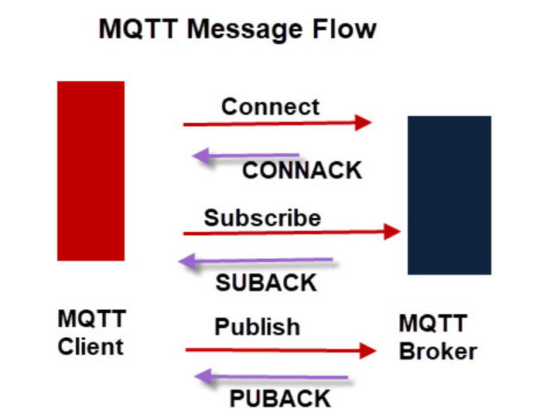
MQTT clients publish a keepalive message at regular intervals (usually 60 seconds) which tells the broker that the client is still connected.

The Client Name or Client ID
All clients are required to have a client name or ID.
The client name is used by the MQTT broker to track subscriptions etc.
Client names must also be unique.
If you attempt to connect to an MQTT broker with the same name as an existing client then the existing client connection is dropped.
Because most MQTT clients will attempt to reconnect following a disconnect this can result in a loop of disconnect and connect.

Routing, Firewall, Operating Systems, Cybersecurity, Linux, Python, Scripting, Network automation, DNS, IoT, Windows Server

From <https://www.shiksha.com/online-courses/articles/networking-interview-questions-answers/>
https://www.shiksha.com/online-courses/articles/networking-interview-questions-answers/

Communication protocols
Monday, February 24, 2025
3:32 PM

USB communication protocol:
